**CSC 1101 – Problem Solving and Programming Laboratory**

**Lab 19 – Omar Faruk**

**25 points – Due November 23, 11pm**

**a)** Save this document with your name and the homework number somewhere in the file name.

**b)** Paste your code and screenshots into the document.

**c)** Submit this document and your .cpp file(s) to the Canvas item where you downloaded this document. Do not submit a zip file but individually attach your files.

You've been hired by *Friendly Fools* to write a C++ console application that manages a list of friends. Create a string array with at least five names of friends. Create the following three functions:

**int menuOption()**

This value function shows the following menu to the user and prompts for and gets an option:

Friendly Fools Menu

1 - List friends

2 - Search friends

9 – Exit

Enter an option:

**void listFriends(string array[], int arraySize)**

This void function loops through the friends array and prints one name per line. It then prints the number of friends in the array.

**int searchFriends(string array[], int arraySize, string key)**

This value function does a linear search through the friends array looking for the key. If found, it returns the index where the key was found. If not found, it returns -1.

In the main function, use a sentinel loop to repeatedly get and process a menu option until the user enters option 9. Define constants for the array size and column widths. Here is a sample application run:

Welcome to Friendly Fools

-------------------------

Friendly Fools Menu

1 - List friends

2 - Search friends

9 - Exit

Enter an option: 1

Friend list

Robert

Phil

Marlene

Julie

Doug

Friend count: 5

Friendly Fools Menu

1 - List friends

2 - Search friends

9 - Exit

Enter an option: 2

Enter a friend to search for: doug

'doug' NOT found.

Friendly Fools Menu

1 - List friends

2 - Search friends

9 - Exit

Enter an option: 2

Enter a friend to search for: Doug

'Doug' found at index 4.

Friendly Fools Menu

1 - List friends

2 - Search friends

9 - Exit

Enter an option: 9

End of Friendly Fools

Run the program with each option and search for names both in and not in the list.

*[your program code here]\**

//==========================================================

//

// Title: My Friends

// Course: CSC 1101

// Lab Number: 19

// Author: Omar Faruk

// Date: 11/22/2020

// Description:

// Creating an application to list and search for friends

// using functions, arrays, if statements, and loops.

//

//==========================================================

#include <cstdlib> // For several general-purpose functions

#include <fstream> // For file handling

#include <iomanip> // For formatted output

#include <iostream> // For cin, cout, and system

#include <string> // For string data type

using namespace std; // So "std::cout" may be abbreviated to "cout"

// Menu function

int menuOption()

{

// Declare variables

int menuOption;

// Show menu and get option

cout << endl

<< "\nFriendly Fools Menu" << endl

<< "1 - List friends" << endl

<< "2 - Search friends" << endl

<< "9 - Exit" << endl << endl

<< "Enter an option: ";

cin >> menuOption;

return menuOption;

}

// List of friends function

void listFriends(string array[], int arraySize)

{

// Declare varables

int friends_count = 0;

// Output friend list and count

cout << endl

<< "Friend list" << endl;

for (int i = 0; i < arraySize; i++)

{

cout << array[i] << endl;

friends_count++;

}

cout << endl << "Friend count: " << friends_count;

}

// Searching of friends function

int searchFriends(string array[], int arraySize, string key)

{

// Declare variables

int index = 0;

// Loop to find index

while (index < arraySize && array[index] != key)

{

index = index + 1;

}

// Return index

if (index == arraySize)

return -1;

else

return index;

}

int main()

{

// Declare constants

const int ARRAYSIZE = 5;

// Declare varaibles

int friend_index = 0;

int menu_option;

string friend_key;

// Declare friends in array

string friendsArray[ARRAYSIZE] = { "Tariq", "Khan", "Malik", "Andrea", "Alicia" };

// Show application header

cout << "Welcome to Friendly Fools!" << endl;

cout << "--------------------------";

// Menu option

menu_option = menuOption();

while (menu_option != 9)

{

// Listing all of friends in array - 1

if (menu_option == 1)

{

listFriends(friendsArray, ARRAYSIZE);

}

// Searching of friends from list - 2

else if (menu_option == 2)

{

cout << "\nEnter a friend to search for: ";

cin >> friend_key;

friend_index = searchFriends(friendsArray, ARRAYSIZE, friend_key);

if (friend_index > -1 && friend_index < ARRAYSIZE)

{

cout << "'" << friend_key << "' found at index " << friend_index;

}

else

{

cout << "'" << friend_key << "' NOT found";

}

}

// Unknown option

else

{

cout << "Invalid option of '" << menu_option << "'."

<< endl;

}

// Get next option

menu_option = menuOption();

}

// Show application close

cout << "\nEnd of Friendly Fools" << endl;

}

*[your program output here]\*\**

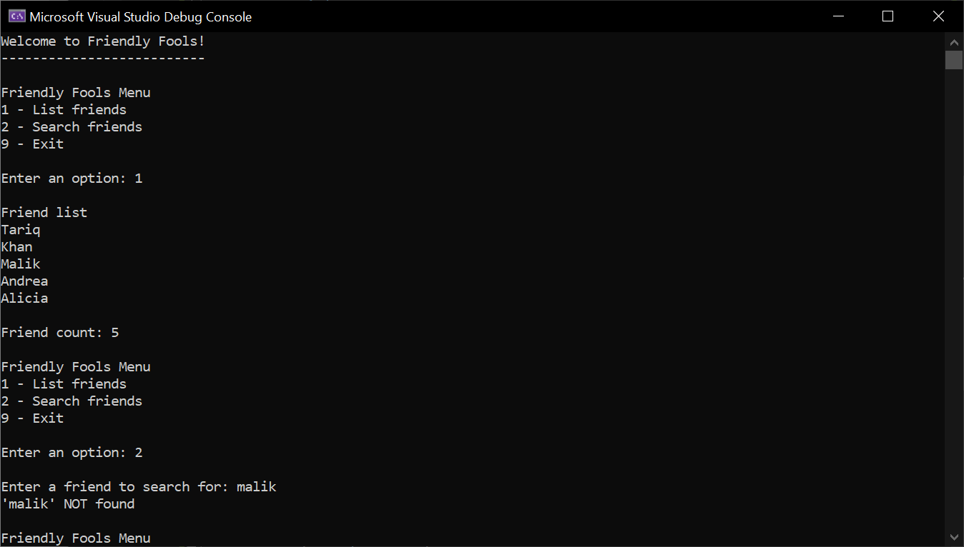

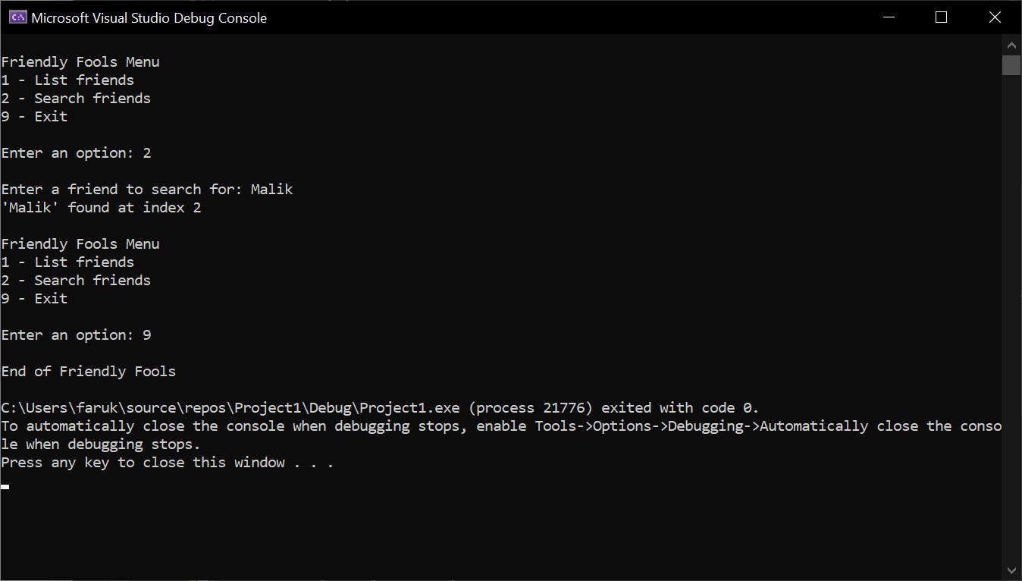

**\* Copying-and-pasting C++ code to a Word document**

**macOS**

1) From within the C++ program, press **command-A** and press **command-C**.

2) From within the Word document, press **command-V**.

**Windows**

1) From within the C++ program, press **CTRL-A** and press **CTRL-C**.

2) From within the Word document, press **CTRL-V**.

**\*\* Copying-and-pasting C++ console application output to a Word document**

**macOS**

1) From the C++ console, press **shift-command-4-space**.

2) From within the Word document, **command-V**.

**Windows**

1) From the C++ console, press **ALT-PrintScreen**.

2) From within the Word document, press **CTRL-V**.